Guidelines for the Creation of the

Internal Quality Assurance Cell (IQAC)

and Submission of Annual Quality Assurance Report (AQAR) in Accredited Institutions
(Revised in October 2013)



NATIONAL ASSESSMENT AND ACCREDITATION COUNCIL
An Autonomous Institution of the University Grants Commission
P. O. Box. No. 1075, Opp: NLSIU, Nagarbhavi, Bangalore - 560 072 India

NAAC

VISION

To make quality the defining element of higher education in India through a combination of self and external quality evaluation, promotion and sustenance initiatives.

MISSION

- To arrange for periodic assessment and accreditation of institutions of higher education or units thereof, or specific academic programmes or projects;

- To stimulate the academic environment for promotion of quality of teaching-learning and research in higher education institutions;

- To encourage self-evaluation, accountability, autonomy and innovations in higher education;

- To undertake quality-related research studies, consultancy and training programmes, and

- To collaborate with other stakeholders of higher education for quality evaluation, promotion and sustenance.

Value Framework
To promote the following core values among the HEIs of the country:
- Contributing to National Development
- Fostering Global Competencies among Students
- Inculcating a Value System among Students
- Promoting the Use of Technology
- Quest for Excellence

Contents

Page Nos.
- Introduction ...... 4
- Objective ...... 4
- Strategies ...... 4
- Functions ...... 5
- Benefits ...... 5
- Composition of the IQAC ...... 5
- The role of coordinator ...... 6
- Operational Features of the IQAC ...... 6
- Monitoring Mechanism ...... 7
- The Annual Quality Assurance Report (AQAR) of the IQAC ...... 8

Part – A
11. Details of the Institution ...... 9
12. IQAC Composition and Activities ...... 12
Part – B
13. Criterion – I: Curricular Aspects ...... 14
14. Criterion – II: Teaching, Learning and Evaluation ...... 15
15. Criterion – III: Research, Consultancy and Extension ...... 17
16. Criterion – IV: Infrastructure and Learning Resources ...... 20
17. Criterion – V: Student Support and Progression ...... 22
18. Criterion – VI: Governance, Leadership and Management ...... 24
19. Criterion – VII: Innovations and Best Practices ...... 27
20. Annexure :I: Abbreviations ...... 29
21. Annexure:II:
Best Practice:I
Best Practice:II
22. Annerxure:III: Feedback
23. Annexure:IV: Composition of IQAC

___________________________
Document revised by: Dr. Ganesh Hegde, Assistant Adviser and B. S. Ponmudiraj, Assistant Adviser, NAAC
Guidelines for the Creation of the

Internal Quality Assurance Cell (IQAC)

and Submission of Annual Quality Assurance Report (AQAR)

in Accredited Institutions

Introduction
In pursuance of its Action Plan for performance evaluation, assessment and accreditation and quality up-gradation of institutions of higher education, the National Assessment and Accreditation Council (NAAC), Bangalore proposes that every accredited institution should establish an Internal Quality Assurance Cell (IQAC) as a post-accreditation quality sustenance measure. Since quality enhancement is a continuous process, the IQAC will become a part of the institution’s system and work towards realisation of the goals of quality enhancement and sustenance. The prime task of the IQAC is to develop a system for conscious, consistent and catalytic improvement in the overall performance of institutions. For this, during the post-accreditation period, it will channelize all efforts and measures of the institution towards promoting its holistic academic excellence.
The guidelines provided in the following pages will guide and facilitate the institution in the creation and operation of the Internal Quality Assurance Cell (IQAC). The work of the IQAC is the first step towards internalization and institutionalization of quality enhancement initiatives. Its success depends upon the sense of belongingness and participation it can inculcate in all the constituents of the institution. It will not be yet another hierarchical structure or a record-keeping exercise in the institution. It will be a facilitative and participative voluntary system/unit/organ of the institution. It has the potential to become a vehicle for ushering in quality enhancement by working out planned interventionist strategies to remove deficiencies and enhance quality like the “Quality Circles” in industries.

Objective
The primary aim of IQAC is

- To develop a system for conscious, consistent and catalytic action to improve the academic and administrative performance of the institution.
- To promote measures for institutional functioning towards quality enhancement through internalization of quality culture and institutionalization of best practices.

Strategies
IQAC shall evolve mechanisms and procedures for

a) Ensuring timely, efficient and progressive performance of academic, administrative and financial tasks;
b) The relevance and quality of academic and research programmes;
c) Equitable access to and affordability of academic programmes for various sections of society;
d) Optimization and integration of modern methods of teaching and learning;
e) The credibility of evaluation procedures;
f) Ensuring the adequacy, maintenance and proper allocation of support structure and services;
g) Sharing of research findings and networking with other institutions in India and abroad.

Functions

Some of the functions expected of the IQAC are:

- Development and application of quality benchmarks/parameters for various academic and administrative activities of the institution;
- Facilitating the creation of a learner-centric environment conducive to quality education and faculty maturation to adopt the required knowledge and technology for participatory teaching and learning process;
- Arrangement for feedback response from students, parents and other stakeholders on quality-related institutional processes;
d) Dissemination of information on various quality parameters of higher education;
e) Organization of inter and intra institutional workshops, seminars on quality related themes and promotion of quality circles;
f) Documentation of the various programmes/activities leading to quality improvement;
g) Acting as a nodal agency of the Institution for coordinating quality-related activities, including adoption and dissemination of best practices;
h) Development and maintenance of institutional database through MIS for the purpose of maintaining /enhancing the institutional quality;
i) Development of Quality Culture in the institution;
j) Preparation of the Annual Quality Assurance Report (AQAR) as per guidelines and parameters of NAAC, to be submitted to NAAC.

Benefits
IQAC will facilitate / contribute
- Ensure heightened level of clarity and focus in institutional functioning towards quality enhancement;
- Ensure internalization of the quality culture;
b) Ensure enhancement and coordination among various activities of the institution and institutionalize all good practices;
c) Provide a sound basis for decision-making to improve institutional functioning;
d) Act as a dynamic system for quality changes in HEIs;
e) Build an organised methodology of documentation and internal communication.

Composition of the IQAC
IQAC may be constituted in every institution under the Chairmanship of the Head of the institution with heads of important academic and administrative units and a few teachers and a few distinguished educationists and representatives of local management and stakeholders.

The composition of the IQAC may be as follows:
1. Chairperson: Head of the Institution
2. A few senior administrative officers
3. Three to eight teachers
4. One member from the Management
5. One/two nominees from local society, Students and Alumni
6. One/two nominees from Employers /Industrialists/stakeholders
7. One of the senior teachers as the coordinator/Director of the IQAC

The composition of the IQAC will depend on the size and complexity of the institution. It helps the institutions in planning and monitoring. IQAC also gives stakeholders or beneficiaries a cross-sectional participation in the institution’s quality enhancement activities. The guidelines given here are only indicative and will help the institutions for quality sustenance activities.
The membership of such nominated members shall be for a period of two years. The IQAC should meet at least once in every quarter. The quorum for the meeting shall be two-third of the total number of members. The agenda, minutes and Action Taken Reports are to be documented with official signatures and maintained electronically in a retrievable format.
It is necessary for the members of the IQAC to shoulder the responsibilities of generating and promoting awareness in the institution and to devote time for working out the procedural details. While selecting these members several precautions need to be taken. A few of them are listed below:
- It is advisable to choose persons from various backgrounds who have earned respect for integrity and excellence in their teaching and research. Moreover, they should be aware of the ground realities of the institutional environment. They should be known for their commitment to improving the quality of teaching and learning.
- It would be appropriate to choose as senior administrators, persons in charge of institutional services such as library, computer center, estate, student welfare, administration, academic tasks, examination and planning and development.
- The management representative should be a person who is aware of the institution’s objectives, limitations and strengths and is committed to its improvement. The local society representatives should be of high social standing and should have made significant contributions to society and in particular to education.

The role of coordinator
The role of the coordinator of the IQAC is crucial in ensuring the effective functioning of all the members. The coordinator of the IQAC may be a senior person with expertise in quality aspects. She/he may be a full-time functionary or, to start with, she/he may be a senior academic /administrator entrusted with the IQAC as an additional responsibility. Secretarial assistance may be facilitated by the administration. It is preferable that the coordinator may have sound knowledge about the computer, its various functions and usage for effective communication.

Operational Features of the IQAC
Quality assurance is a by-product of ongoing efforts to define the objectives of an institution, to have a work plan to achieve them and to specify the checks and balances to evaluate the degree to which each of the tasks is fulfilled. Hence devotion and commitment to improvement rather than mere institutional control is the basis for devising procedures and instruments for assuring quality. The right balance between the health and growth of an institution needs to be struck. The IQAC has to ensure that whatever is done in the institution for “education” is done efficiently and effectively with high standards. In order to do this, the IQAC will have to first establish procedures and modalities to collect data and information on various aspects of institutional functioning.

The coordinator of the IQAC and the secretary will have a major role in implementing these functions. The IQAC may derive major support from the already existing units and mechanisms that contribute to the functions listed above. The operational features and functions discussed so far are broad-based to facilitate institutions towards academic excellence and institutions may adapt them to their specific needs.

The institutions need to submit yearly the Annual Quality Assurance Report (AQAR) to NAAC. A functional Internal Quality Assurance Cell (IQAC) and timely submission of Annual Quality Assurance Reports (AQARs) are the Minimum Institutional Requirements (MIR) to volunteer for second, third or subsequent cycle’s accreditation. During the institutional visit the NAAC peer teams will interact with the IQACs to know the progress, functioning as well quality sustenance initiatives undertaken by them.

The Annual Quality Assurance Reports (AQAR) may be the part of the Annual Report. The AQAR shall be approved by the statutory bodies of the HEIs (such as Syndicate, Governing Council/Board) for the follow up action for necessary quality enhancement measures.

The Higher Education Institutions (HEI) shall submit the AQAR regularly to NAAC. The IQACs may create its exclusive window on its institutional website and regularly upload/ report on its activities, as well as for hosting the AQAR.

The NAAC Accredited institutions need to submit only the soft copy as word file (.doc/.docx) through e-mail (capuaqar@gmail.com). The file name needs to be submitted with Track ID of the institution and College Name or EC number. For example MHCOGN16601-Samudra Arts and Science College, Taliamegu-Maharashtra.doc or EC_32_A&A_143 dated 3-5-2004-Samudra Arts and Science College, Taliamegu-Maharashtra.doc. The Higher Education Institutions need not submit the printed/hard copy to NAAC. The acknowledgements would be sent to the institutions through e-mail.

The Annual Quality Assurance Report (AQAR) of the IQAC

All NAAC accredited institutions will submit an annual self-reviewed progress report to NAAC, through its IQAC. The report is to detail the tangible results achieved in key areas, specifically identified by the institutional IQAC at the beginning of the academic year. The AQAR will detail the results of the perspective plan worked out by the IQAC. (Note: The AQAR period would be the Academic Year. For example, July 1, 2012 to June 30, 2013)

Part – A
Year 2014-15
AQAR for the year (for example 2013-14)

1. Details of the Institution
INDIRA GANDHI MAHILA MAHAVIDAYALAYA

1.1 Name of the Institution
Karnal Road, Kaithal
1.2 Address Line 1
Near PNB Karnal Road
Address Line 2
Kaithal
City/Town
Haryana
State
136027
Pin Code
igmmvkaithal@gmail.com
Institution e-mail address
01746-222336
Contact Nos.
Dr.(Mrs.) Sadhna Thukral
Principal

Name of the Head of the Institution:
01746-234546

Tel. No. with STD Code:
9466521006
Mobile:
Mrs. Neerja Uppal
Name of the IQAC Co-ordinator:
9896725020
Mobile:
igmmvkaithal@gmail.com
IQAC e-mail address:

HRCOGN10325
1.3 NAAC Track ID (For ex. MHCOGN 18879)
OR

1.4 NAAC Executive Committee No. & Date:
MARCH 21,2003
(For Example EC/32/A&A/143 dated 3-5-2004.
This EC no. is available in the right corner- bottom
of your institution’s Accreditation Certificate)

www.igpgmmv.com
1.5 Website address:
www.igpgmmv.com/downloads

Web-link of the AQAR:
For ex. http://www.ladykeanecollege.edu.in/AQAR2012-13.doc
1.6 Accreditation Details
Sl. No. | Cycle | Grade | CGPA | Year of Accreditation | Validity Period
1 | 1st Cycle | B | 71% | 2003 | 5years
2 | 2nd Cycle
3 | 3rd Cycle
4 | 4th Cycle

1.7 Date of Establishment of IQAC : DD/MM/YYYY
26/05/2014

1.8 Details of the previous year’s AQAR submitted to NAAC after the latest Assessment and Accreditation by NAAC ((for example AQAR 2010-11submitted to NAAC on 12-10-2011)
- AQAR ___________N.A____________ __________________ (DD/MM/YYYY)4
- AQAR__________________ ________________________ (DD/MM/YYYY)
- AQAR__________________ _______________________ (DD/MM/YYYY)
- AQAR__________________ _______________________ (DD/MM/YYYY)
1.9 Institutional Status
√

University State Central Deemed Private
√

Affiliated College Yes No
√

Constituent College Yes No

√

Autonomous college of UGC Yes No

√

Regulatory Agency approved Institution Yes No
(eg. AICTE, BCI, MCI, PCI, NCI)

√

Type of Institution Co-education Men Women
√

Urban Rural Tribal

√

√

√

Financial Status Grant-in-aid UGC 2(f) UGC 12B

Grant-in-aid + Self Financing Totally Self-financing
√

1.10 Type of Faculty/Programme
√

Arts Science Commerce Law PEI (Phys Edu)
√

√

TEI (Edu) Engineering Health Science Management

- PGDCA,BCA, BMC

Others (Specify)
KURUKSHETRA UNIVERSITY,KURUKSHETRA
1.11 Name of the Affiliating University (for the Colleges)
√
1.12 Special status conferred by Central/ State Government-- UGC/CSIR/DST/DBT/ICMR etc
N.A
Autonomy by State/Central Govt. / University
N.A

N.A
University with Potential for Excellence UGC-CPE
N.A

N.A

DST Star Scheme UGC-CE
N.A

N.A

UGC-Special Assistance Programme DST-FIST
N.A

NA
UGC-Innovative PG programmes Any other (Specify)
N.A

UGC-COP Programmes
2. IQAC Composition and Activities
3
2.1 No. of Teachers
2
2.2 No. of Administrative/Technical staff
1
2.3 No. of students
2.4 No. of Management representatives
1
1
2.5 No. of Alumni
2. 6 No. of any other stakeholder and
1
community representatives
1
2.7 No. of Employers/ Industrialists
1
2.8 No. of other External Experts
2.9 Total No. of members
12
2.10 No. of IQAC meetings held
4
5
2.11 No. of meetings with various stakeholders: No. Faculty
2
1
1
1
Non-Teaching Staff Students Alumni Others

√

2.12 Has IQAC received any funding from UGC during the year? Yes No
NO
If yes, mention the amount
2.13 Seminars and Conferences (only quality related)
(i) No. of Seminars/Conferences/ Workshops/Symposia organized by the IQAC
NA

Total Nos. International National State Institution Level

(ii) Themes
2.14 Significant Activities and contributions made by IQAC
1) MEETING WITH HEADS OF VARIOUS DEPARMENTS 2) MEETING OF TEACING PLAN
3) PLANS FOR IMPROVEMENT IN STUDENTS PERFORMANCE,DISCIPLINE WAS MAINTAINED

2.15 Plan of Action by IQAC/Outcome
The plan of action chalked out by the IQAC in the beginning of the year towards quality
enhancement and the outcome achieved by the end of the year *
Plan of Action | Achievements
PLAN FOR ALL AROUND DEVELOPMENT OF STUDENTS | DIVISION OF SYLLABUS.MERIT IN UNIVERSITY.  MERIT IN UNIVERSITY.  POSITION IN STATE LEVEL IN EXTRA CURRICULAR ACTIVITIES.
* Attach the Academic Calendar of the year as Annexure.
√

2.15 Whether the AQAR was placed in statutory body Yes No
√.A

Management Syndicate Any other body
Provide the details of the action taken
MEETING WAS HELD TO DISCUSS THE VARIOUS METHODS FOR QUALITY ENHANCEMENT:
- STRICTNESS IN ATTENDANCE
- REGULAR CLASS TESTS
- INTIMATION TO THE PARENTS OF ALL THE WARDS & MEETING WITH THE PARENTS OF DEFAULTERS
- SPECIAL CLASSES FOR WEAK STUDENTS AND BOOKS WERE PROVIDED TO MERIT AND POOR STUDENTS
- ATTENDANCE IS MADE COMPULSORY ACCORDING TO UNIVERSITY NORMS.

Part – B
Criterion – I

1. Curricular Aspects

1.1 Details about Academic Programmes
Level of the Programme | Number of existing Programmes | Number of programmes added during the year | Number of self-financing programmes | Number of value added / Career Oriented programmes
PhD | NIL
PG | 04 | 01 | 04
UG | 05
PG Diploma | 01
Advanced Diploma
Diploma | 01
Certificate | 01
Others
Total

Interdisciplinary
Innovative

1.2 (i) Flexibility of the Curriculum: CBCS/Core/Elective option / Open options
(ii) Pattern of programmes:
Pattern | Number of programmes
Semester | ALL
Trimester
Annual

1.3 Feedback from stakeholders* Alumni Parents Employers Students
(On all aspects)

√

Mode of feedback : Online Manual Co-operating schools (for PEI)
*Please provide an analysis of the feedback in the Annexure

1.4 Whether there is any revision/update of regulation or syllabi, if yes, mention their salient aspects.
YES,SYLLABUS IS REGULARIZED ACCORDING TO CURRENT UPDATES BY KURUKSHETRA UNIVERSITY,KURUKSHETRA

1.5 Any new Department/Centre introduced during the year. If yes, give details.
M.Sc. MATHS HAS BEEN INTRODUCED

Criterion – II
2. Teaching, Learning and Evaluation
2.1 Total No. of permanent faculty
Total | Asst. Professors | Associate Professors | Professors | Others
04 |  | 03 |  | 01
02
2.2 No. of permanent faculty with Ph.D.
2.3 No. of Faculty Positions Recruited (R) and Vacant (V) during the year
Asst. Professors |  | Associate Professors |  | Professors |  | Others |  | Total
R | V | R | V | R | V | R | V | R | V
 |  | 03 | 15 |  |  | 01 |  | 04 | 15
NIL
NIL
59
2.4 No. of Guest and Visiting faculty and Temporary faculty

2.5 Faculty participation in conferences and symposia: NA

No. of Faculty | International level | National level | State level
Attended Seminars/ Workshops
Presented papers
Resource Persons

2.6 Innovative processes adopted by the institution in Teaching and Learning:
EDUSAT PROGRAMME WAS IMPLEMENTED FOR QUALITY IN TEACHING AND LEARNING.

93% PER SEM
2.7 Total No. of actual teaching days
during this academic year
2.8 Examination/ Evaluation Reforms initiated by
DOUBLE VALUATION
the Institution (for example: Open Book Examination, Bar Coding,
Double Valuation, Photocopy, Online Multiple Choice Questions)

01

2.9 No. of faculty members involved in curriculum
restructuring/revision/syllabus development
as member of Board of Study/Faculty/Curriculum Development workshop
85% TO 90%
2.10 Average percentage of attendance of students

2.11 Course/Programme wise
distribution of pass percentage :

Title of the Programme | Total no. of students appeared | Division
Title of the Programme | Total no. of students appeared | Distinction | I | II | III | Pass
BA-I | 436 |  | 72 | 40 |  | 125
BA-I
BA-II | 221 |  | 59 | 02 |  | 61
BA-I1 | 222 | 01 | 70 | 08 |  | 78
BA-III | 207 |  | 35 | 61 |  | 126
BA-I11 | 202 |  | 62 | 55 |  | 124
B.Sc.-I(Med) | 38 |  | 09 | 06 |  | 20
B.Sc.-I(Med)
B.Sc.-I(N.Med) | 163 |  | 69 | 38 |  | 107
B.Sc.-I(N.Med)
B.Sc.-II(N.Med) | 142 |  | 96 | 02 |  | 98
B.Sc.-I1(N.Med)
B.Sc.-III(N.Med) | 97 |  | 17 | 18 |  | 79
B.Sc.-III(N.Med) | 97 | 01 | 87 | 1 |  | 88
B.Sc.--I(C.Sc) | 71 |  | 47 | 15 |  | 62
B.Sc.--I(C.Sc)
B.Sc.-II(C.Sc) | 44 |  | 21 | 15 |  | 36
B.Sc.-II(C.Sc) | 44 |  | 19 | 12 |  | 31
B.Sc.-III(C.Sc) | 34 |  | 14 | 07 |  | 21
B.Sc.-III(C.Sc) | 32 |  | 26 | 03 |  | 29
B.Com.-1(G) | 180 | 03 | 67 | 14 |  | 81
B.Com.-1(G)
B.Com.-II(G) | 149 | 01 | 60 | 07 |  | 67
B.Com.-II(G) | 150 |  | 84 | 25 |  | 109
B.Com,-III(G) | 137 |  | 62 | 52 |  | 119
B.Com.-III(G) | 138 | 01 | 87 | 35 |  | 123
BCA-1 | 20 |  | 06 | - |  | 06
BCA-1
BCA-II | 07 |  | 02 | - |  | 02
BCA-11
BCA-III | 06 |  | 03 |  |  | 03
BCA-111 | 05 |  | 04 | 01 |  | 05
BMC I | 21 |  | 13 | 06 |  | 19
BMC I
BMC II | 10 |  | 8 | 1 |  | 9
BMC II | 10 |  | 5 | 3 |  | 8
BMC III | 06 |  | 06 |  |  | 06
BMC III | 06 |  | 06 |  |  | 06
MA English(P) | 32 | 01 | 27 | 3 |  | 30
MA English(P) | 27 | 01 | 18 | 04 |  | 22
MA English(F) | 19 | 01 | 7 | 11 |  | 18
MA English(F) | 18 |  | 5 | 7 |  | 12
MA Eco(P) | 27 |  | 14 | 7 |  | 21
MA Eco(P) | 25 | 03 | 6 | 12 |  | 18
MA Eco(F) | 20 |  | 16 | 4 |  | 20
MA Eco(F) | 20 | 04 | 17 |  |  | 17
M.Com(P) | 54 |  | 21 | 28 |  | 49
M.Com(P) | 49 |  | 17 | 22 |  | 39
M.Com(F) | 51 |  | 27 |  |  | 27
M.Com(F) | 50 |  | 37 |  |  | 37
MSC MATHS | 51 |  | 29 | 9 |  | 38
PGDCA
Title of the Programme | Total no. of students appeared | Division
Title of the Programme | Total no. of students appeared | Distinction % | I % | II % | III % | Pass %

2.12 How does IQAC Contribute/Monitor/Evaluate the Teaching & Learning processes :
SUGGESTIONS BY IQAC ARE GIVEN IN REGULAR MEETINGS ,STRENGTH AND WEAKNESS OF VARIOUS DEPARTMENTS ARE OBSERVED MINUTELY.
2.13 Initiatives undertaken towards faculty development
Faculty / Staff Development Programmes | Number of faculty  benefitted
Refresher courses | NA
UGC – Faculty Improvement Programme | NIL
HRD programmes | NA
Orientation programmes | NA
Faculty exchange programme | NA
Staff training conducted by the university | NA
Staff training conducted by other institutions | NA
Summer / Winter schools, Workshops, etc. | NA
Others | NA
2.14 Details of Administrative and Technical staff
Category | Number of Permanent  Employees | Number of Vacant  Positions | Number of permanent positions filled during the Year | Number of positions filled temporarily
Administrative Staff | 04 | 13
Technical Staff | 01 | NIL
Criterion – III
3. Research, Consultancy and Extension
3.1 Initiatives of the IQAC in Sensitizing/Promoting Research Climate in the institution
FACULTY MEMBERS ARE MOTIVATED TO IMPROVE THEIR SKILLS.TEACHERS ARE PROVIDED WITH EVERY FACILITY LIKE BOOKS AND COMPUTERS TO ENHANCE THEIR TEACHING SKILLS

3.2 Details regarding major projects
 | Completed | Ongoing | Sanctioned | Submitted
Number | NA
Outlay in Rs. Lakhs | NA

3.3 Details regarding minor projects
 | Completed | Ongoing | Sanctioned | Submitted
Number | NA
NA | NA

3.4 Details on research publications
 | International | National | Others
Peer Review Journals | NIL
Non-Peer Review Journals | NIL
e-Journals | NIL
Conference proceedings | NIL

3.5 Details on Impact factor of publications:
NA
NA
NA
NA
Range Average h-index Nos. in SCOPUS
3.6 Research funds sanctioned and received from various funding agencies, industry and other organisations NA
Nature of the Project | Duration  Year | Name of the  funding Agency | Total grant  sanctioned | Received
Major projects
Minor Projects
Interdisciplinary Projects
Industry sponsored
Projects sponsored by the University/ College
Students research projects
(other than compulsory by the University)
Any other(Specify)
Total

3.7 No. of books published i) With ISBN No. Chapters in Edited Books
NA

NA

ii) Without ISBN No.
3.8 No. of University Departments receiving funds from NA
NA
NA
UGC-SAP CAS DST-FIST
NA
NA
NA
DPE DBT Scheme/funds
3.9 For colleges Autonomy CPE DBT Star Scheme

INSPIRE CE Any Other (specify)

NA

3.10 Revenue generated through consultancy
Level | International | National | State | University | College
Number | NA
Sponsoring agencies | NA
3.11 No. of conferences
organized by the Institution
03

3.12 No. of faculty served as experts, chairpersons or resource persons
NA

NA
NA

3.13 No. of collaborations International National Any other
08
3.14 No. of linkages created during this year
3.15 Total budget for research for current year in lakhs :
NA
NA

NA
From Funding agency From Management of University/College
Total
NA

3.16 No. of patents received this year : NA
Type of Patent |  | Number
National | Applied | NA
National | Granted | NA
International | Applied | NA
International | Granted | NA
Commercialised | Applied | NA
Commercialised | Granted | NA

3.17 No. of research awards/ recognitions received by faculty and research fellows : NA
Of the institute in the year
Total | International | National | State | University | Dist | College

3.18 No. of faculty from the Institution
NA

who are Ph. D. Guides
and students registered under them
NA

3.19 No. of Ph.D. awarded by faculty from the Institution
NO

3.20 No. of Research scholars receiving the Fellowships (Newly enrolled + existing ones)
NA

JRF SRF Project Fellows Any other

3.21 No. of students Participated in NSS events:
10
NA
University level State level
National level International level
NA
NA

3.22 No. of students participated in NCC events:
NA

NA

University level State level
National level International level
NA

NA

3.23 No. of Awards won in NSS:
University level State level
NA
NA
National level International level
NA
NA

3.24 No. of Awards won in NCC:
University level State level
NA

NA

National level International level
NA

NA

3.25 No. of Extension activities organized
05
11
University forum College forum
02
02
01
NCC NSS Any other

3.26 Major Activities during the year in the sphere of extension activities and Institutional Social Responsibility
- DEBATES , DECLAMATION, QUIZ COMPETITIONS
- POSTER MAKING, SLOGAN WRITNG, COLLAGE MAKING, MEHNDI ,SKIT COMPETITIONS,RANGOLI ON VARIOU SOCIAL ISSUES.

Criterion – IV
4. Infrastructure and Learning Resources
4.1 Details of increase in infrastructure facilities:
Facilities | Existing | Newly created | Source of Fund | Total
Campus area | 5 ACRE |  |  | 5 ACER
Class rooms | 31 | 09 |  | 40
Laboratories | 03 | 06 |  | 09
Seminar Halls | 01 |  |  | 01
No. of important equipments purchased (≥ 1-0 lakh) during the current year.
Value of the equipment purchased during the year (Rs. in Lakhs)
Others

4.2 Computerization of administration and library:
YES

4.3 Library services:
 | Existing |  | Newly added |  | Total
 | No. | Value | No. | Value | No. | Value
Text Books | 20652 | 1888174 | 1894 | 338206 | 22546 | 2226380
Reference Books | 297 | 59575 | 2 | 790 | 299 | 60365
e-Books
Journals | 11 | 0 | 3 | 0 | 14 | FREE OF COST
e-Journals
Digital Database
CD & Video
Others (specify)

4.4 Technology up gradation (overall): NA
 | Total Computers | Computer Labs | Internet | Browsing Centres | Computer Centres | Office | Depart-ments | Others
Existing
Added
Total

4.5 Computer, Internet access, training to teachers and students and any other programme for technology
upgradation (Networking, e-Governance etc.)
NIL

4.6 Amount spent on maintenance in lakhs :

i) ICT
690095/-
ii) Campus Infrastructure and facilities

iii) Equipments

iv) Others

690095/-

Total :

Criterion – V
5. Student Support and Progression
5.1 Contribution of IQAC in enhancing awareness about Student Support Services
TIME TO TIME VARIOUS MEETINGS FOR VARIOUS SCHEME ARENOTIFIED TO THE STUDENTS. EFFORTS MADE BY INSTITUTON FOR PROGRESSION.REGULAR ATTENDENCE/WEEKLY TEST/UNIT TEST/ASSIGNMENT ARE ORGANISED TO IMPROVE STUDY.

5.2 Efforts made by the institution for tracking the progression
MONTHLY TEST ,DAILY ATTENENCE AND ASSIGNMENTS ARE TAKEN INTO ACCOUNT FOR TRACKING THE PROGRESSION.

5.3 (a) Total Number of students
UG | PG | Ph. D. | Others
2054 | 267

(b) No. of students outside the state
NA
NA
(c) No. of international students

Men Women
No | %
No | %
Last Year |  |  |  |  |  | This Year
General | SC | ST | OBC | Physically Challenged | Total | General | SC | ST | OBC | Physically Challenged | Total
1369 | 151 |  | 389 |  | 1909 | 1873 | 125 |  | 323 |  | 2321
Demand ratio Dropout %
5.4 Details of student support mechanism for coaching for competitive examinations (If any)
ADD ON COURSES IN FUNCTIONAL ENGLISH NWAS STARTED HELP THE STUDENTS IN COMPETITIVE EXAM. INTERNET FACILITIES ARE PROVIDED TO THE STUDENTS AND BOOKS FOR COMPETITIVE EXAM ARE PROVIDEDFOR STUDENTS.

No. of students beneficiaries
25% TO 35 %

5.5 No. of students qualified in these examinations NIL

NET SET/SLET GATE CAT
IAS/IPS etc State PSC UPSC Others

5.6 Details of student counselling and career guidance
1)ACADEMIC COUNSELLING IS PROVIDED TO THE STUDENT AT THE TIME OF ADMISSION AND DURIN THE SESSION
2)PERSONAL COUNSELLING IN TUTORIALS, WOMEN CELL AND N.S.S. PROGRAMMES.
3) COUNSELLING BY CAREER GUIDANCE AND PLACEMENT CELL

25%
No. of students benefitted

5.7 Details of campus placement
On campus |  |  | Off Campus
Number of Organizations Visited | Number of Students Participated | Number of Students Placed | Number of Students Placed
NA | NA | NA | NA

5.8 Details of gender sensitization programmes
RALLIES WERE TAKEN OUT AGAINST FEMALE FOETICIDE .VARIOUS COMPETITIONS LIKE POSTER MAKING, SLOGAN WRITING WERE ORGANISED TO MAKE THE STUDENTS AWARE OF GENDER INEQUALITY

5.9 Students Activities
5.9.1 No. of students participated in Sports, Games and other events
06
07
NIL
State/ University level National level International level
No. of students participated in cultural events
34
State/ University level National level International level
NA

NA

5.9.2 No. of medals /awards won by students in Sports, Games and other events
01
NIL

06
Sports : State/ University level National level International level
18
05
NIL
Cultural: State/ University level National level International level

5.10 Scholarships and Financial Support
 | Number of  students | Amount
Financial support from institution
Financial support from government | 220 | 565565
Financial support from other sources | 03 | 12000
Number of students who received International/ National recognitions

5.11 Student organised / initiatives
NA

NIL

NIL

Fairs : State/ University level National level International level

Exhibition: State/ University level National level International level
06
5.12 No. of social initiatives undertaken by the students

5.13 Major grievances of students (if any) redressed: _____NA_________________________________

Criterion – VI
6. Governance, Leadership and Management
6.1 State the Vision and Mission of the institution
TO STREGHTEN AND SHARPEN THEOVER ALL PERSONALITY OF STUDENTS SO THAT THEY CAN FACE THE CHALLENGES OF LIFE.

6.2 Does the Institution has a management Information System
YES, INFORMATION IS PROVIDED TO THE RIGHT PERSON AT RIGHT PLACE AND AT A RIGHT TIME. MEETING ARE HELD WITH TEACHERS AND STUDENTS FROM TIME TO TIME.

6.3 Quality improvement strategies adopted by the institution for each of the following:
6.3.1 Curriculum Development
SUGGESTIONS ARE CONVEYED TO UNIVERSITIES BY THE MEMBERS OF BOARD OF OF STUDIES FOR ENRICH THE CURRICULUM SO THAT STUDENT GETTING THE KNOWLEDGE FOR ALL THE ASPECTS OF SUBJECTS & COCURRICULUM ACTIVITY

6.3.2 Teaching and Learning
LATEST TEACHING AIDS(LIKE SMART BOARDS,PROJECTORS &COMPUTER ARE BEING AVAILED FOR EFFECTIVE LEARNING. TEACHING SCHEDULES ARE DECIDED BY TAKING INTO ACCOUNT THE SYLLABUS ,LEARNING LEVEL OF CONCERNED STUDENTS AND TIME CONSTRAINTS OF SEMESTERSYSTEM. SPECIAL CLASSES FOR WEAK STUDENTS

6.3.3 Examination and Evaluation
CLASS TESTS,ASSIGNMENTS AND LAB WORK ARE EVALUATED TO MAKE THE STUDENTS COME IN A BENCHMARK.DEPARTMENTAL MEETINGS ARE HELD FROM TIME TO TIME.PARENTS ARE INFORMED BY SMS AND MEETINGS ARE HELD IF REQUIRED.

6.3.4 Research and Development
- NIL

6.3.5 Library, ICT and physical infrastructure / instrumentation
LIBRARY IS WELL EQUIPPED WITH LATEST EDITION OF BOOKS AND UPDATED ACCORDING TO THE LATEST CURRICULUM AND DEMAND OF TEACHERS AND STUDENTS.BOOKS AND MAGAZINES ARE PURCHASED FOR COMPETITIVE EXAMS ALSO.CREATION,EXPANSION & UPGRADATION OF INFRASTRUCTURE TO FACILITATE FOR EFFECTIVE TEACHING & LEARNING.

6.3.6 Human Resource Management
REQUIRED RESOURCES ARE PROVIDED BY MANAGEMENT AND FUNDS ARE RISED ACCORDINGLY

6.3.7 Faculty and Staff recruitment
FACULTY & STAFF ARE RECRUITED ON NEED BASIS AS PER MERIT

6.3.8 Industry Interaction / Collaboration
NA

6.3.9 Admission of Students
STUDENTS ARE ADMITTED ON THE BASIS OF MERIT AS PER KUK RULES & REGULATIONS.

6.4 Welfare schemes for:
Teaching | PROVISION OF LOANS FROM P/F
Non teaching | PROVSION OF LOANS FROM P/F
Students | FEE CONCESSION, AND SCHOLARSHIP BY MANAGEMENT AND GOVERNMENT

NA
6.5 Total corpus fund generated
√

6.6 Whether annual financial audit has been done Yes No

6.7 Whether Academic and Administrative Audit (AAA) has been done?
Audit Type | External |  | Internal
Audit Type | Yes/No | Agency | Yes/No | Authority
Academic
Administrative |  |  | YES | CA

6.8 Does the University/ Autonomous College declares results within 30 days?

√

For UG Programmes Yes No

√

For PG Programmes Yes No
6.9 What efforts are made by the University/ Autonomous College for Examination Reforms?
SEMESTER SYSTEM IS BEING IMPLEMENTED 2010-11 AS EXAMINATION REFORMS.

6.10 What efforts are made by the University to promote autonomy in the affiliated/constituent colleges?
NA

6.11 Activities and support from the Alumni Association
ALUMNI MEET IS ARRANGED ANNUALLY AND FEEDBACK IS TAKEN FROM THEM.LATEST DEVELOPMENT OF THE COLLEGE IS DISCUSSED WITH THE ALUMNI MEMBERS

6.12 Activities and support from the Parent – Teacher Association
PARENTS TEACHERS MEETING IS HELD TIME TO TIME ,.PARENTS ARE INFORMED ABOUT THE PROGRESS OF THEIR WARDS.

6.13 Development programmes for support staff
- AT THE TIME OF NEED LOAN IS GIVEN BY THE MANAGEMENT.
- FEE CONCESSION TO THE WARDS
- RESIDENTIAL FACILITIES ARE PROVIDED.

6.14 Initiatives taken by the institution to make the campus eco-friendly
1) PLANS ARE GROWN IN THE COLLEGE.
2) CLEANINESS DRIVE IN THE COLLEGE IS UNDERTAKEN BY NSS VOLUNTEERS.
3) SEMINAR WAS ORGANISED.
S4) STUDENTS ARE ADVISED NOT TO WASTE PAER , ELECTRICITY AND WATER.

Criterion – VII
7. Innovations and Best Practices
7.1 Innovations introduced during this academic year which have created a positive impact on the
functioning of the institution. Give details.
• TO PROVIDE ECO – FRIENDLY ENVIRONMENT
• TO CONSERVE ENERGY AND WATER
- FOR THE COMNFORT OF STUDENTS CENTRAL COOLER IS INSTALLED IN COMMON ROOM AND LIBRARY.

7.2 Provide the Action Taken Report (ATR) based on the plan of action decided upon at the
beginning of the year
REGULAR PLANTATION ACTIVITIES PROVIDES AN ECO FRIENDLY ENVIORNMENT.

7.3 Give two Best Practices of the institution (please see the format in the NAAC Self-study Manuals)
- QUALITY IMPROVEMENT IN ACADEMICS
- REGULAR CLASSES & STRICT WATCH ON DISCIPLINE.
- ENVIORNMENT CONSCIOUSNESS.
- TOPPERS ARE AWARDED BY MEDALS AND CASH PRIZES.
- QUIZ,SLOGAN WRITING DECLAMATION AND SPEECHES ARE ORGANISED FOR ENVIORNMENTAL AWARENESS.

*Provide the details in annexure (annexure need to be numbered as i, ii,iii)
7.4 Contribution to environmental awareness / protection
- TREE PLANTATION.
- CONSERVATION OF WATER AND ELECTRICITY.
- USE OF LOW CONSUMPTION ELECTRIC EQUIPMENT.
- KEEPING LIGHTS AND FAN OFF.

√

7.5 Whether environmental audit was conducted? Yes No

7.6 Any other relevant information the institution wishes to add. (for example SWOT Analysis)
- DROP OUT RATE OF STUDENTS
- LANGUAGE PROBLEM
- LACK OF FUNDS DUE TO RURAL BACKGROUND

8. Plans of institution for next year
PLAN FOR STARTING THE M.Sc. PHYSICS AND M.Sc. CHEMISTRY

Name:- Mrs. Neerja Uppal Name:- Dr.Mrs. Sadhna Thukral


Signature of the Coordinator, IQAC Signature of the Chairperson, IQAC

_______***_______

Annexure I

Abbreviations:
CAS - Career Advanced Scheme
CAT - Common Admission Test
CBCS - Choice Based Credit System
CE - Centre for Excellence
COP - Career Oriented Programme
CPE - College with Potential for Excellence
DPE - Department with Potential for Excellence
GATE - Graduate Aptitude Test
NET - National Eligibility Test
PEI - Physical Education Institution
SAP - Special Assistance Programme
SF - Self Financing
SLET - State Level Eligibility Test
TEI - Teacher Education Institution
UPE - University with Potential Excellence
UPSC - Union Public Service Commission

***************

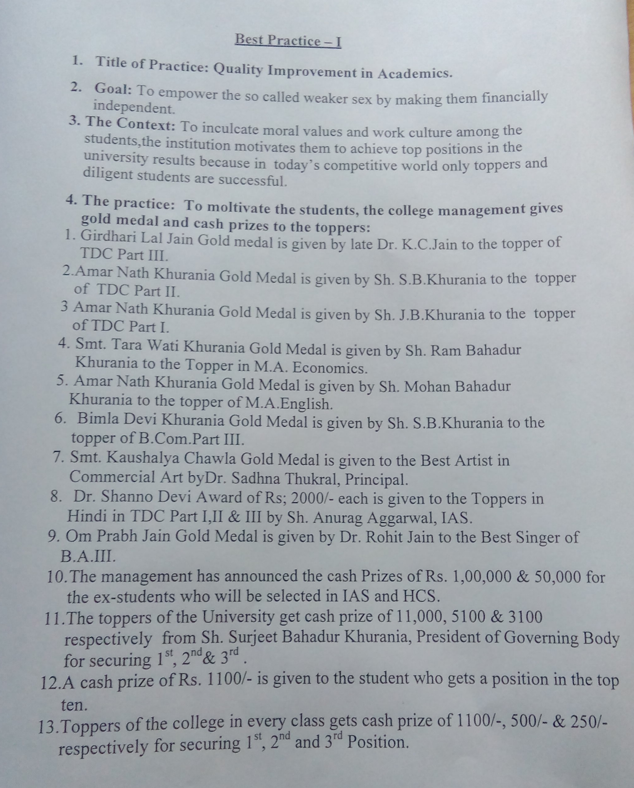
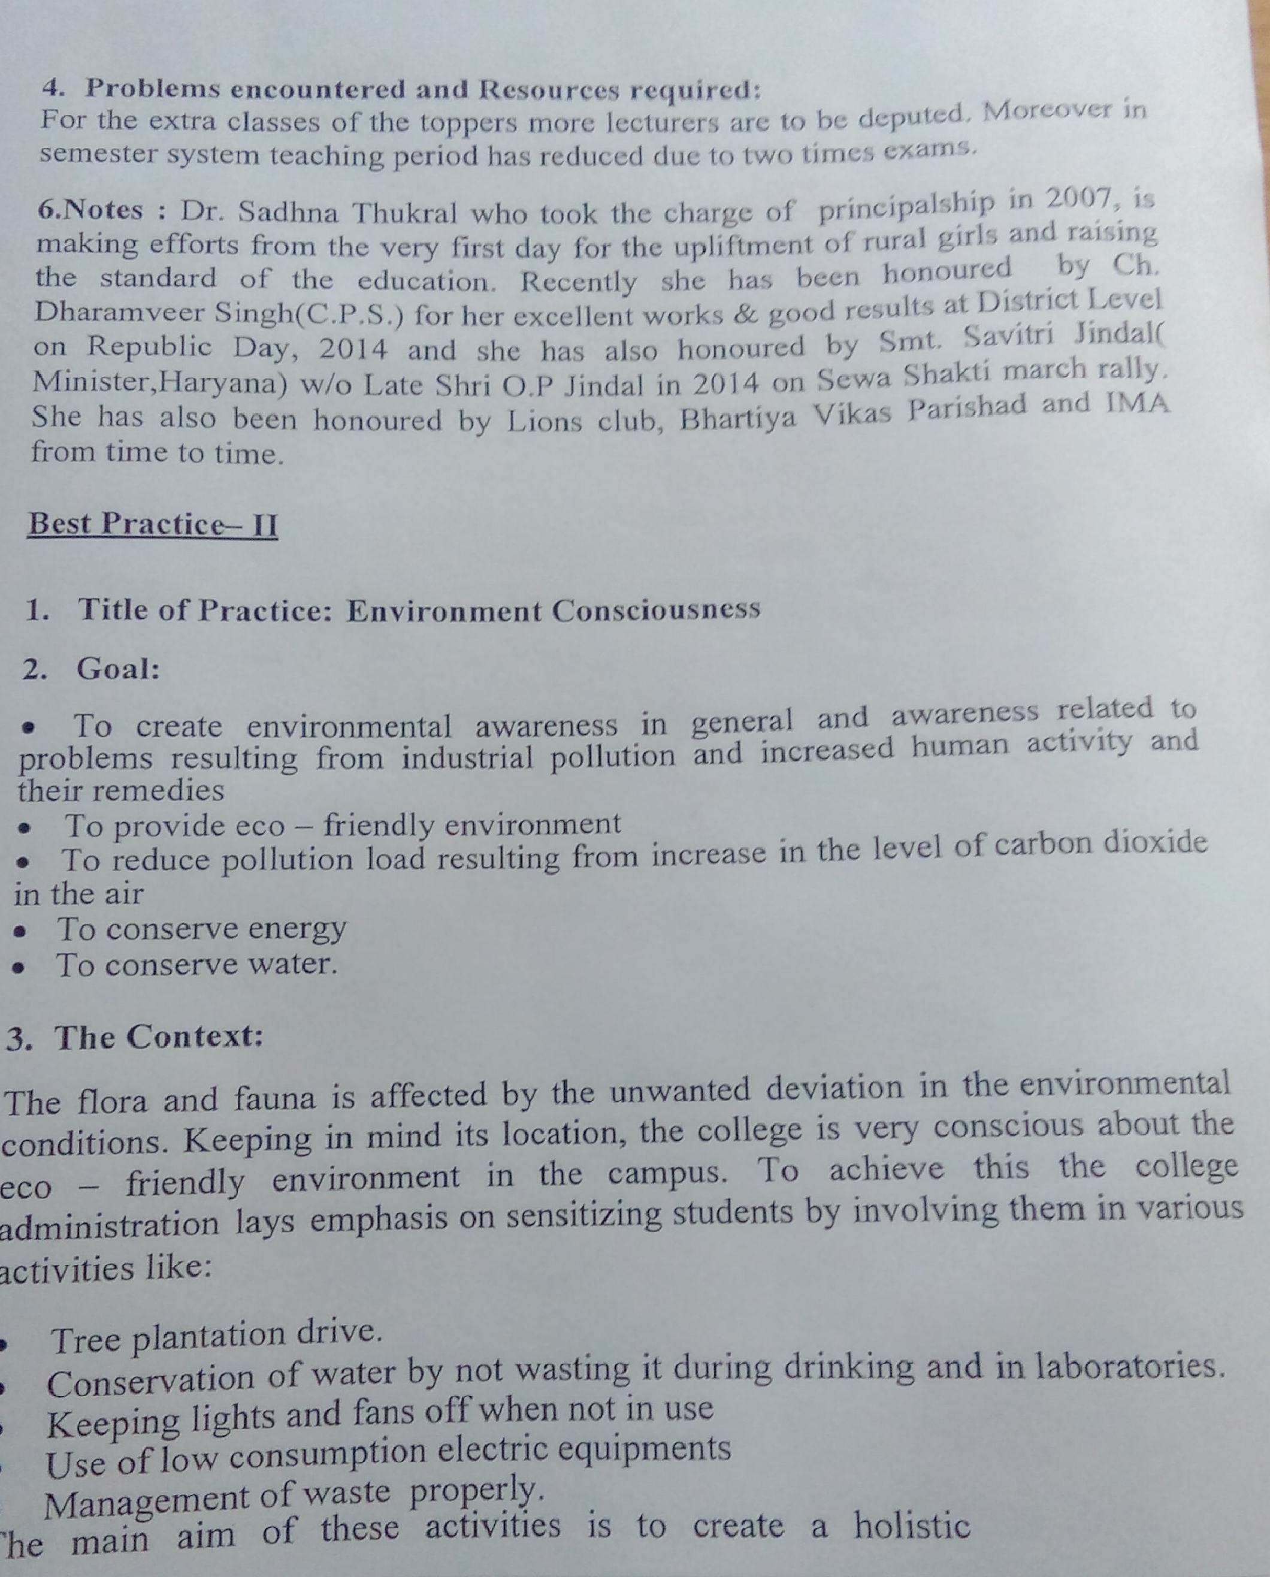
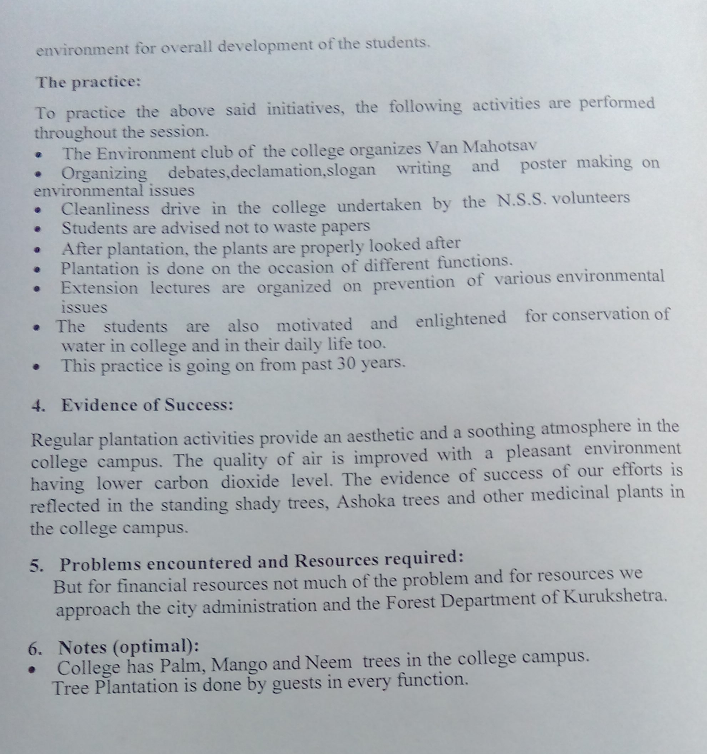

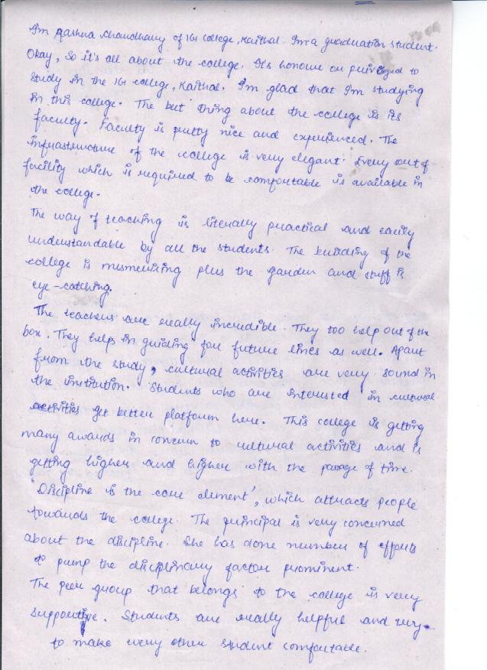

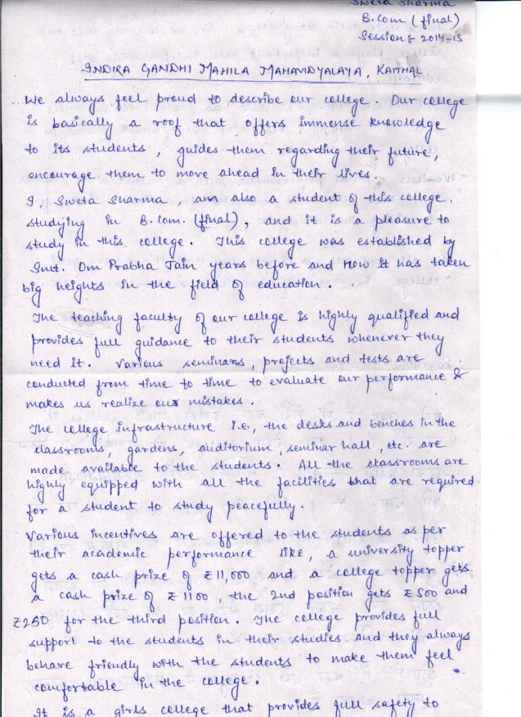

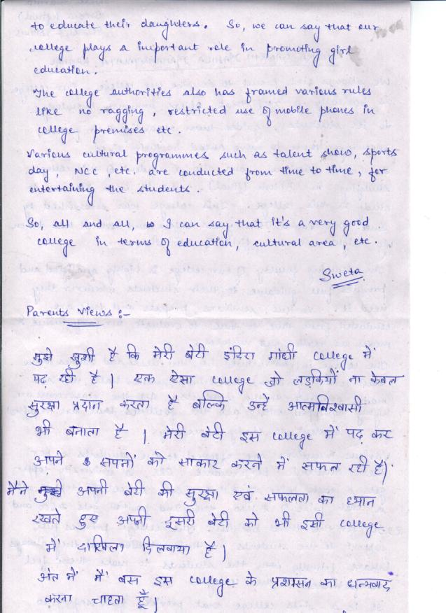

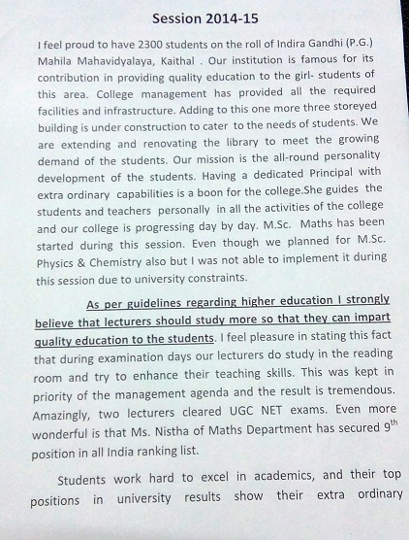

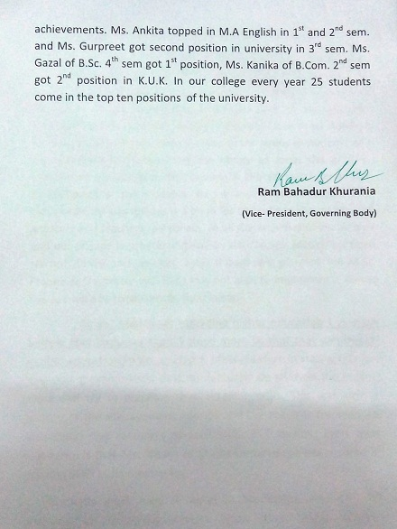

Annexure:IV

COMPOSITION OF IQAC FOR THE SESSION 2014-15

1. Chairperson: Dr.(Mrs.) Sadhna Thukral
2. A few senior administrative officers: 1) Mr. Vijay Gupta (Head Clerk)
3. Three to eight teachers: 1) Mrs.Renu Chopra
2) Mrs. Meenakshi Kaushal
3) Mrs. Shashi Gulati
4) Mrs. Neerja Uppal
5) Mrs Anita Bansal

4. One member from the Management: Sh. Subash Sharma
5. One/two nominees from:
1) local society/Parents: a) Sh. Fateh Singh
b) Sh. Pawan Malhotra
2) Students a) Ms. Neha Malhotra
3)Alumni a) Ms. Nirmla
6. One/two nominees from Employers /Industrialists/stakeholders:
Vice President- Sh. Ram Bahadur Khurania

7. One of the senior teachers as the coordinator/Director of the IQAC:
Mrs. Neerja Uppal

